Useful ROS Commands

Useful video explaining setting up publisher/subscriber: <https://www.youtube.com/watch?v=2Cmdu6mkxD0>

$ rostopic info {topic}

$ rostopic info front_angle_avg

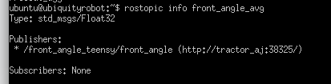

$ rosmsg show {type}

$ rosmsg show std_msgs/Float32

ubuntu@ubiquityrobot:~$ rosmsg show std_msgs/Float32

float32 data

ubuntu@ubiquityrobot:~$

$ rosnode info /steer_motor_teensy/steer_motor